A. Log on to the PaP site:

<https://isante.ugp.ht/consolidatedId/isante>

B. Search for the site to be restored using the menu item ***Entretien des cliniques de iSanté*** on the consolidated server: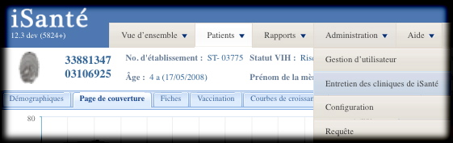

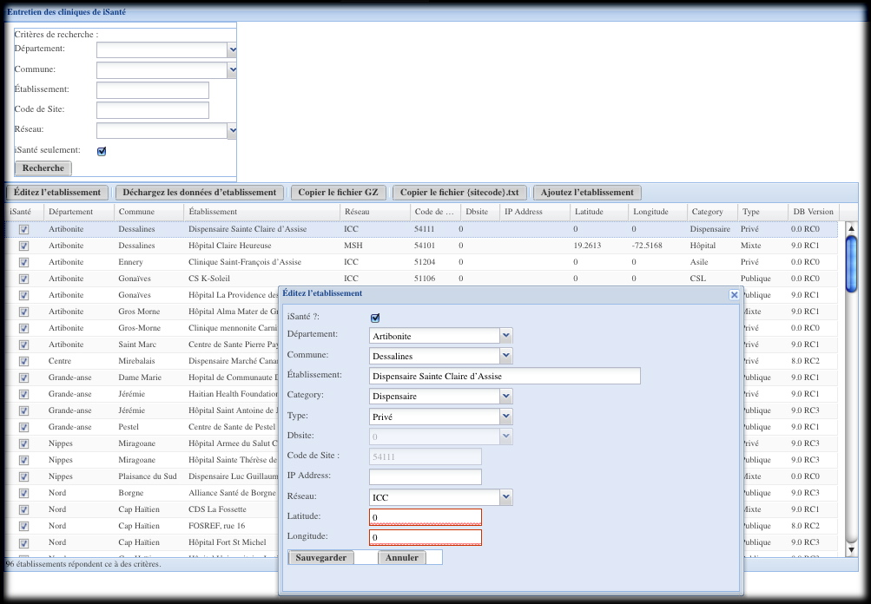

C. Unload the site’s data with the button **Déchargez les données d'etablissement**. The data file is automatically placed on the server here:

/var/backups/itech/unloads/

After a successful unload, the above directory should contain the following files:

{sitecode}errors.txt contains any errors during the unload (should be zero size)

{sitecode}.txt summarizes the data unloaded

{sitecode}.csv.gz contains the site’s data

{sitecode}.csv.gz will be used to re-load the site’s server in the next step. The {sitecode}.txt file will be empty until the gz file is completely unloaded.

P***lease wait long enough be sure the gz file is completely unloaded*** before proceeding to the next step (D).

D. Copy the unloaded {sitecode}.csv.gz file from the consolidated server location above so that it can be applied to the new server. You can copy the {sitecode}.csv.gz file to your client computer using the **Copier le fichier GZ** button.

For comparison purposes later, be sure to copy the unload statistics file {sitecode}.txt, using the button **Copier le fichier {sitecode}.txt**. Remember, this file will be empty until the gz file is completely written to disk, so if it is empty, you need to wait longer for the gz file.

E. When logged on to the server to be reloaded, load the new server with the site’s data:

sudo sh

cd /var/www/isante/replication

perl updateTarget.pl --file {sitecode}.csv.gz > {sitecode}.txt 2> {sitecode}errors.txt

This load process could take some time, particularly for any site with more than 200 patients.

F. Verify that the load was successful by comparing the {sitecode}.txt file generated on the consolidated site in step C) with the {sitecode}.txt file generated in step E).